Pointing State and Physical Side of pier for German mounts
Peter Simpson – February 2009 (Revised October 2009)

Introduction
One of the key goals of ASCOM is to present a consistent interface for application developers where all devices appear to work in the same way despite having multitudinous detail differences in their implementations. Conform is a tool developed to confirm driver consistency with the ASCOM standards and this paper sets out how it will test the telescope SideOfPier and DestinationSideOfPier properties, for German mounts, to determine that the pointing state rather than the physical side of pier is reported, as required by the Telescope V2 specification dated 16th January 2008.

Background
Like other mounts, a German mount has two pointing states and two mechanical RA and DEC axis angle pairs that allow the telescope to point at an object in the sky. Usually, for practical reasons, one of these is favoured over the other, e.g. in one, the telescope will be above the counterweights and in the other below and potentially in danger of colliding with the pier. In this discussion I will refer to the pointing states as the “normal” state and the “through the pole” state.
For the purposes of this description I am applying the commonly used GEM design rule that the mount firmware favours the pointing state where the telescope is above the counterweights. Most mounts do allow the user to override this rule at times through mechanics such as slew limits and flip margins but I want to describe the basic mode of operation before dealing with edge cases such as these.
The concepts will be explored through a practical example but the arguments work similarly for other latitudes and the other hemisphere. Figure 1 is a planisphere representation of the sky as seen from the northern hemisphere around latitude 50 degrees. The solid lines going through the pole represent lines of right ascension, represented as hour angles and the dashed lines represents particular declinations that, in one case, is circumpolar and in the other is not. The letters A to D represent particular sky co-ordinates represented by hour angle / declination co-ordinate pairs.
The German mount, when looking at position A, assuming it obeys the “scope above counterweight” rule, will be on the west side of the pier looking upwards towards the east at the RA corresponding to hour angle -3. I am going to designate the mount pointing state at this moment as the “normal” state.
Now consider what happens when moving to point B. The scope is above the counterweight at this mechanical RA angle and it can reach point B simply by moving the DEC axis so that the telescopes gaze moves upwards in declination, through the pole and downwards in declination to point B. Despite no change in the mechanical RA angle, the hour angle has changed as the scope moved through the pole into its other pointing state, the “through the pole” state. So, at point B the telescope remains on the west side of the mount and the pointing state is now “through the pole”.

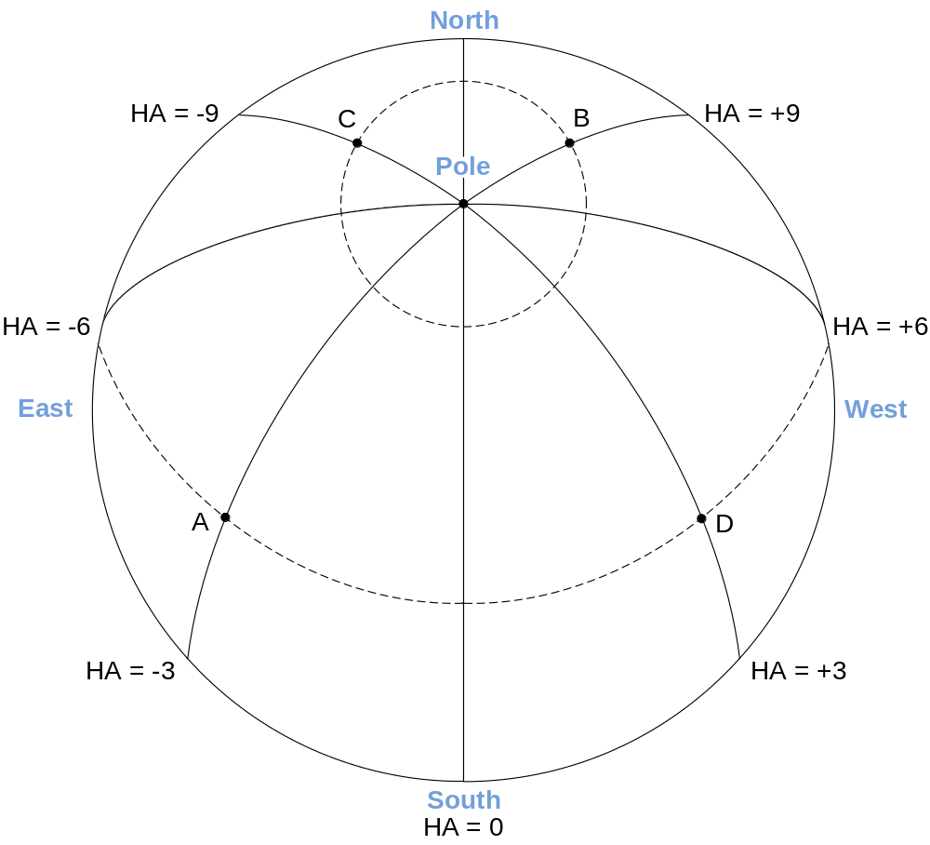
Figure 1 Model of the sky
So, how does the mount get to point C and also keep the telescope above the counterweights? It moves its mechanical RA angle until it lines up with the +3, -9 hour angle lines and in doing so, moves to the east side of the pier, keeping the telescope above the counterweights. The telescope however, will now be pointing towards the point C’ which has the correct DEC co-ordinate but the wrong HA co-ordinate and so the mount now moves the telescope gaze upwards along the DEC axis, back through the pole and down again, ending up at point C. In doing so, the mount returns from the “through the pole” state to the “normal” state. So the telescope is now on the east side of the pier in the normal pointing state.
Finally, it gets to point D by leaving the mechanical RA angle as it is and by simply moving the DEC axis back through the pole, once again entering the “through the pole” state and then downwards to point D. The telescope thus finishes on the east side of the pier in the “through the pole” state.
The changes of physical side of pier and pointing state are colour coded in figures 2 and 3.

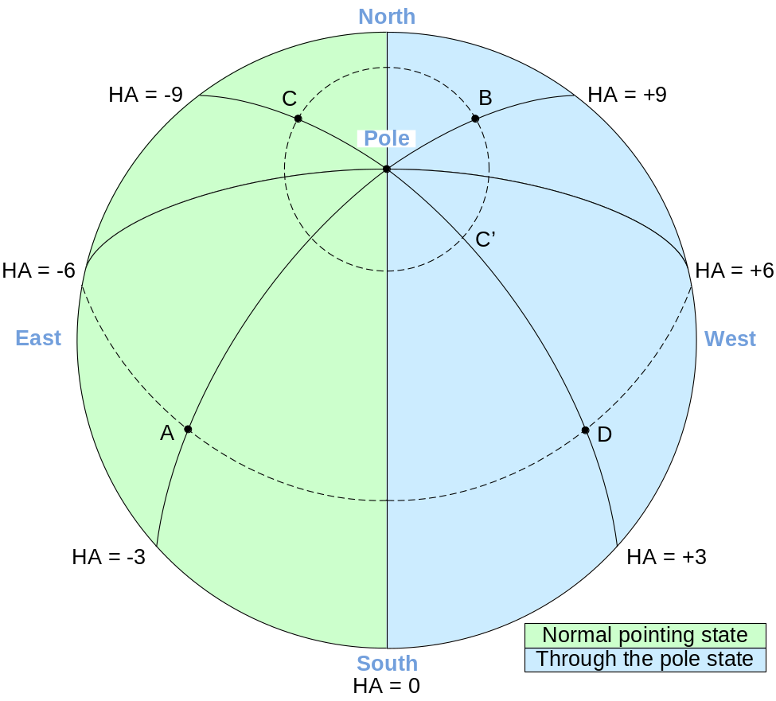
Figure 2 Pointing states at locations A, B, C and D

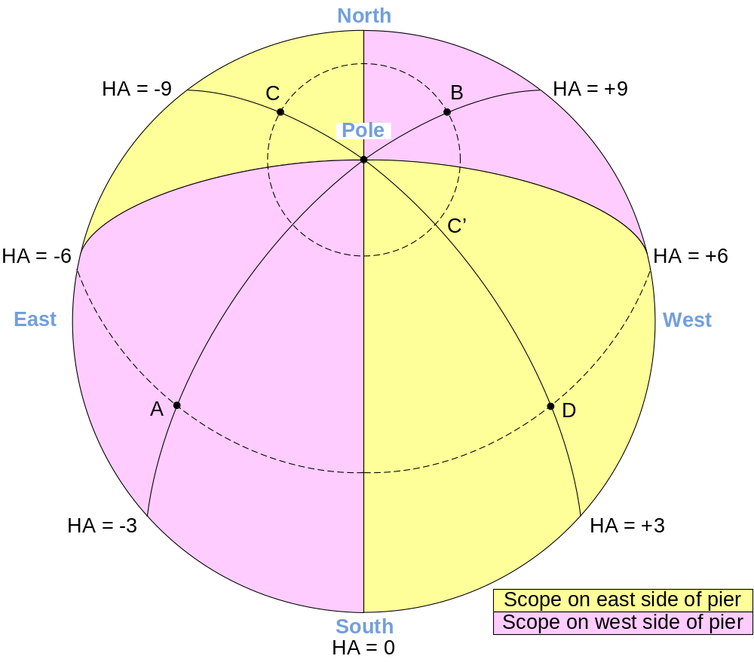
Figure 3 Physical side of pier at locations A, B, C and D

Conform and ASCOM SideOfPier
The ASCOM telescope specification has one property called SideOfPier which can take values of pierEast and pierWest and it is intended that this expresses the pointing state of the mount. By moving to the four positions A, B, C and D and recording the SideOfPier values returned, Conform can determine whether the driver reports physical side of pier or pointing state.
Since the “normal” and “through the pole” mount pointing states are a matter of choice for the telescope designer, a convention is required on how to translate the mount pointing state into an ASCOM SideOfPier state. The current convention is that pierEast is mapped to the pointing state that pertains when the telescope is on the east side of the mount and pointing at locations on the celestial equator.
Using this convention and the modelling described earlier, Conform expects a driver that reports pointing state to return an ASCOM SideofPier pattern for the four quadrants that looks like this:
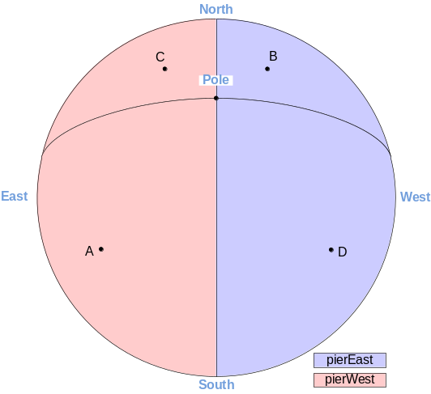
Figure 4 SideOfPier reports pointing state
If Conform finds the following pattern it will conclude that the driver is reporting physical side of pier and flag this as a conformance issue. Any other patterns will also be flagged as incorrect.
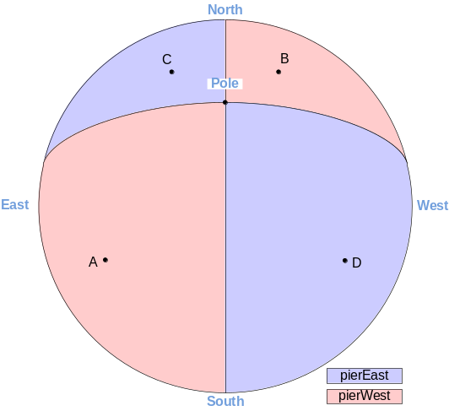
Figure 5 SideOfPier reports physical pier side

Exceptions to the rule
Flip margins, slew limits etc. are tools that mount designers provide to allow the observer to override the basic design principle that the telescope should choose the pointing state that puts the telescope above the counterweights at all times. Conform deliberately avoids testing in sky areas where these conveniences are frequently implemented. It chooses hour angles well away from the meridian and wherever possible chooses declinations that keep observation points away from the horizon and the pole.

Conform Test Implementation
Conform first moves to hour angle -3 and records the SideOfPier and the destination side of pier of this hour angle. It then determines the DestinationSideOfPier for hour angle +3 and slews there where it records the SideOfPier returned by the driver finally returning to the start point at hour angle -3. This process is repeated for hour angles -9 and +9.
At this point Conform has four DestinationSideOfPier values and four SideOfPier values that it can compare with expected patterns and report accordingly. Needless to say, the DestinationSideOfPier values and the SideOfPier values should be consistent with each other!

Acknowledgements
I would like to thank Patrick Wallace, Chris Rowland, Tim Long and Bob Denny for helpful discussion and advice in building my understanding of this subject.

Document Updates
Version 1.0 - February 2009 – Original release
Version 1.1 - October 2009 – Corrected captions for figures 4 and 5. In Version 1.0, figure 4 had figure 5’s caption and vice versa.

